 | YEAR 12 MATHEMATICS SPECIALIST  SEMESTER TWO 2017  QUESTIONS OF REVIEW 6: Integration

Name: _______________________

Wednesday 9th August Time: 30 minutes Mark /24
Calculator free.

[5 marks – 1, 2 and 2]

Simplify

Express in the partial fraction form

Determine

[10 marks – 1, 3, 3 and 3]

Simplify by inspection

Use the substitution to evaluate

Evaluate by using the substitution

Evaluate

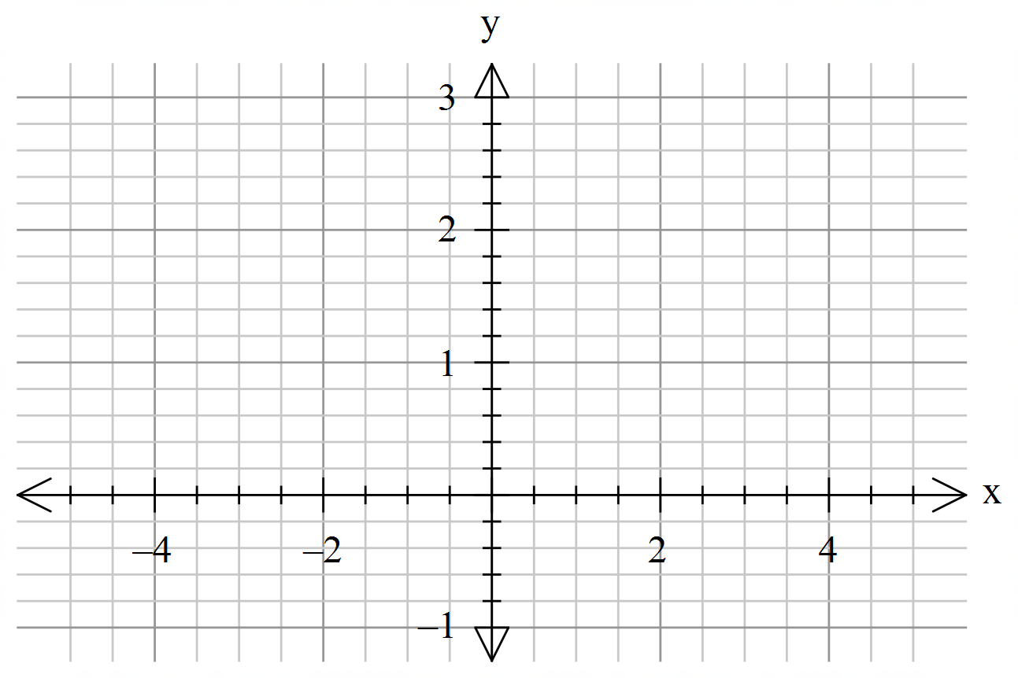 [5 marks – 1, 1, 1 and 2]

Draw a quick sketch of

Describe the quantity represented by each of the integrals:

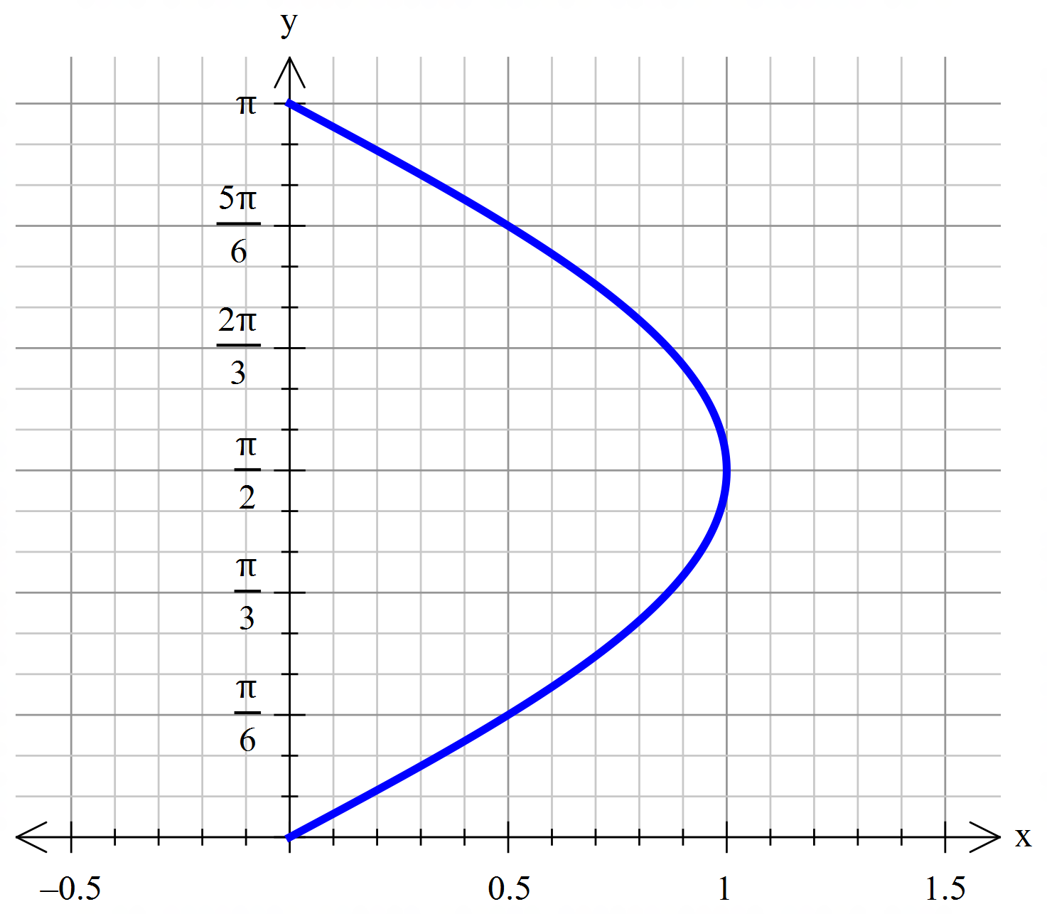

[4 marks]

What is the volume generated when the curve , for , is revolved through 360° about the y axis?

